Paper Manufacturing in Spring City
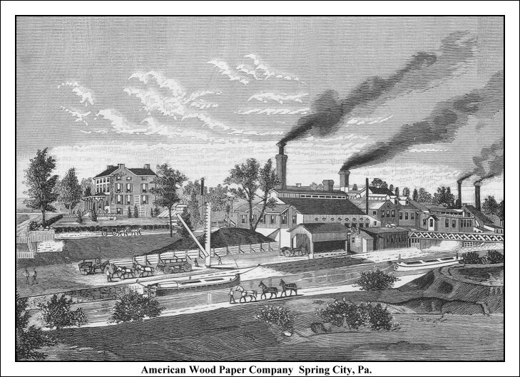
.
On April 9th, 1847 Shyrock & Company purchased a large tract of land from Frederick Yost. This property was situated north of Bridge Street, and stretched from the Schuylkill River to what is now Church Street. That year the company built a small paper mill and a residence on the property. That residence now widely known as the “Paper Mill Mansion” is one remaining link to a local business that went out of existence over 100 years ago.
The first paper produced at the mill was of very poor quality and was sold as wrapping paper or brown paper presumably suitable for the wrapping of dry goods. This type of paper was generally produced from straw. The paper was made in various sizes and shipped out on the canal in 150-pound bolts.
The early years saw a succession of owners and reconfiguration of management. Here are some of the firm names- Shyrock, Paxton & Knight; Nixon & Company; Bursler & Stearly; William Shearer; Burgess, Keen & Ladd. The early years were not successful in terms of financial results. It was not until the production of wood paper pulp that this local business began to flourish. The very first consignment of wood paper pulp, one ton, was shipped in 1862 to Mr. James McGargee, then a paper maker on the Wissahicken Creek, several miles above Philadelphia.
In 1863 The American Wood Paper Company was incorporated with two million dollars capital. Burgess and Keen controlled the company while Burgess served as the president. It was in this same year that the company built a large paper mill at Manayunk.

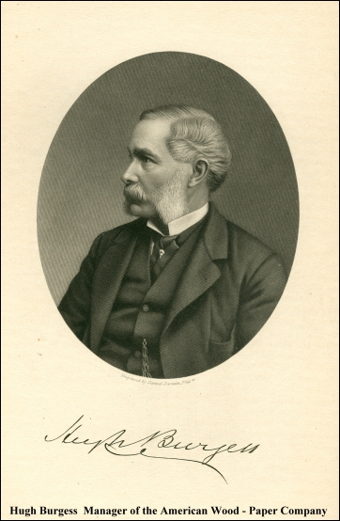
These works had the capacity for making twenty tons daily while the Spring City site was producing nine tons daily. The wood pulp made by the American Wood Paper Co. was sent to all parts of the country, and was converted into five grades of paper by the paper mills in various localities.
Mr. Burgess was born in Reading, England, spending his early life there. In the year 1851, working with Mr. Charles Watt, he succeeded in developing a chemical process that enabled them to produce good white paper from wood pulp at a paper-mill at Boxmoor, in Hertfordshire. The London Journal printed some number of its weekly issues on this paper, and this was the first paper made from wood that could be used for printing purposes. In 1852, Mr. Burgess was invited to come over to America to introduce the wood-pulp process. He landed in New York City early in 1853, and in the same year was introduced to Mr. M. L. Keen, and with him began to make wood-pulp in the old engine-house of the Wilmington and Philadelphia Railroad, at Gray's Ferry. It is interesting to note that Burgess was granted a British patent #1942 for his unique process of using pressure boiled wood chips in an alkali mixture to manufacture white paper on August 19, 1853. The paper-pulp made from wood here was manufactured into paper at the paper-mills at Maylandville, close by, and this was the first wood-paper fit for printing ever made in America. In 1854 this paper process was started at the mill in Spring City and brought into completion. Material such as: straw, corn-stalks, bamboo, cane, etc. were all tried at this mill in the manufacture of white paper-pulp, but no material had been found so suitable for paper-making purposes as wood. It was at this local mill that the papermaking industry was entirely revolutionized and the chemical process perfected.
It has been reported that in later years one of the main clients of the mill was the United States Government, purchasing high quality heavy calendar paper. All manufacturing ceased in 1893. There were 125 persons on the payroll at this time. Some explanations have been passed down over the years pointing to the scarcity of poplar wood as one of the reasons. What should not be overlooked is the untimely death of Mr. Burgess that same year. He was 67 at the time and his body was returned to his homeland, England, for his burial.

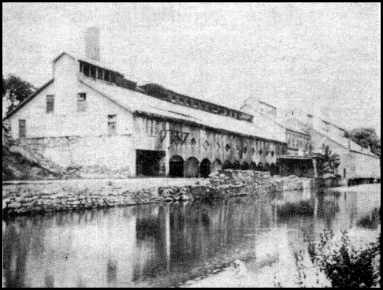
In the above actual photo circa 1890 you can see the American Wood Paper Co.
The Pennsylvania Shafting Works purchased the old mill in 1904 and began manufacturing of iron steam shafts and cold pressed metal parts. The postcard
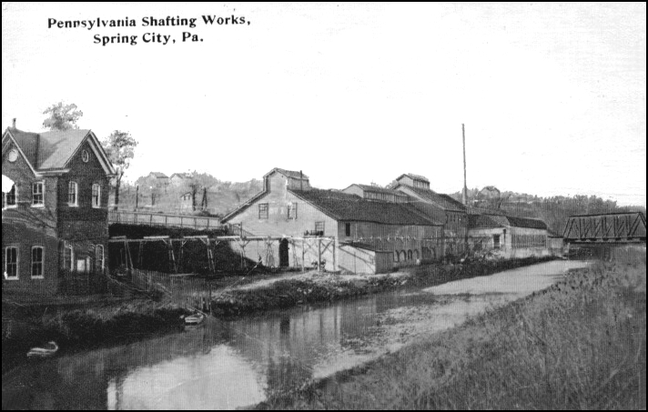
view below is circa 1910 and shows the Pennsylvania Shafting Works. Located in this area today is the A. C. Miller Concrete Co.

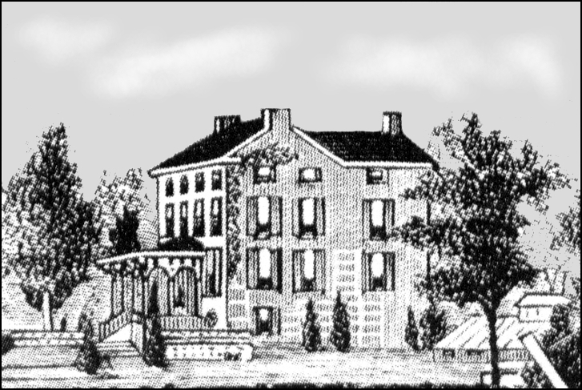
Original Paper Mill Mansion Sketch
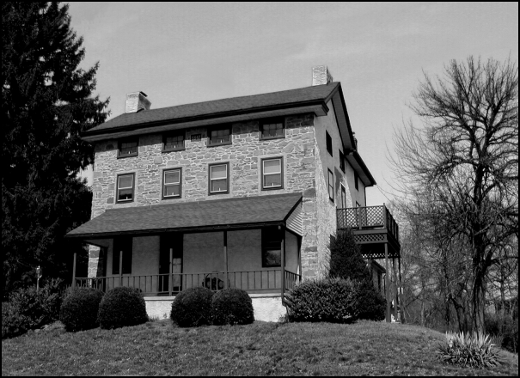

View of Mansion at 115 Bridge Street as it appears in 2005

WCB

Spring-Ford Area Historical Society Newsletter Insert for November 2005

